1. Study of Existing System and System Requirements (Marks 15)

• Define the existing system and its working

• What are the issues/problems with the existing system?

• How are you going to improve on the issues/problems with the existing system?

• State the steps of the current system(System Requirement Specification)

Answer --- not elaborated

1. No password storage system installed. Users forget their passwords or some important textual data. Even if they write it down in a text document- offline or online, it may be visible to other users.
2. Loss of passwords and other crucial textual data.
3. Deploying a password and data management web application which is secure in every respect and user’s data is hidden from backend developers and other users as well.
4. **This question is doubtful to me.**

2. Analysis (Marks 20)

• Context diagram

• Data flow diagram (Level I, II,III as applicable)

• Functional decomposition Diagram

1. Context diagram

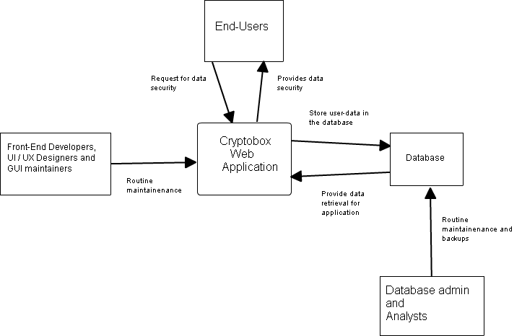

The interactions of the Cryptobox web application with developers, users and the database are shown as above. Front end developers and user experience designers may interact with the application to improve the GUI. End users or our target audience, the employees interact with the app to store their data and retrieve it when needed. Database provides the web app with user data while the app interacts with database to store user data. Database administrator is responsible for backup and maintainenance of the database.

1. Data flow diagram

The flow of data and control in the application is depicted by the following data flow diagram.

The project makes use of following components:

1. Java Servlets
2. Static HTML pages
3. Java server pages(JSP)
4. Oracle 10g database for backend
5. External jar APIs servlet-api.jar and ojdbc14.jar

Servlets involve the files:

OldUserInput.java

NewUserInput.java

AddNewData.java

RemoveProfile.java

Update.java

JSP files include:

Decrypt.jsp

Display.jsp

Edit.jsp

Html files include:

Index.html

newIndex.html

mediate.html

newData.html

Confirm.html

Exit.html

Two servlets namely JavaCon.java and OraConnection.java are used for Java Database Connectivity, to establish connection with the Oracle 10g Database.

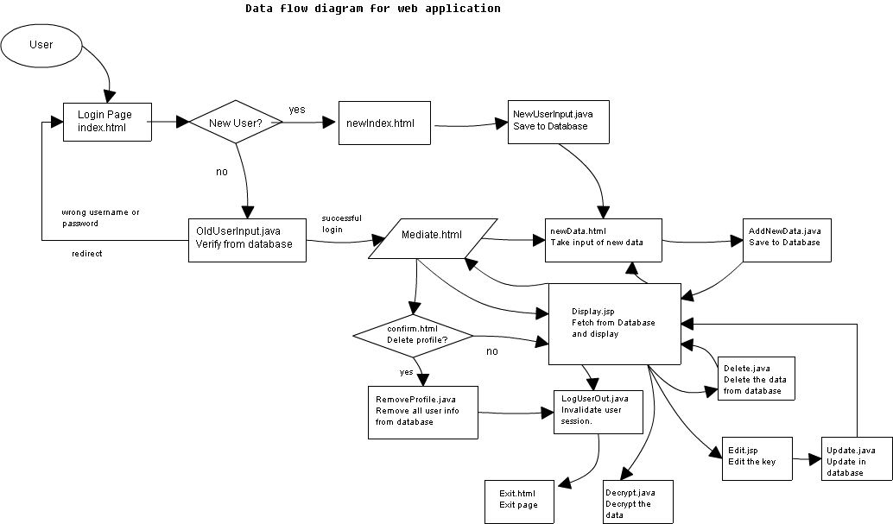

1. Functional Decomposition Diagram

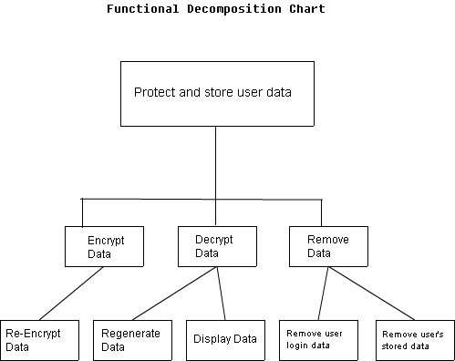

Functional decomposition is a term that engineers use to describe a set of steps in

which they break down the overall function of a device, system, or process into its

smaller parts. This is usually accomplished through thoughtful analysis and team

discussions of project information and the result is a chart that describes the problem

and or solutions in increasing detail.

A function is simply a task that is performed by a device, system, or process.

Decomposition is a process of breaking down. In this lesson, we will be breaking

down functions into their smaller parts.

A general function is a function that requires other functions to work in order to

take place. A general function may also be a sub function, since it may both depend

on and be depended on by other functions.

A subfunction is a function that has to work in order for a more general function to

take place. Remember, a subfunction may also be a general function.

A basic function is a function that has no smaller subfunctions.

For the Cryptobox Web application, the prominent objective is to protect and store user data.

It can be classified into following functions and subfunctions:

1. Encrypt the Data
2. Re-encryption
3. Decrypt the Data
4. Regeneration of original data from the encrypted data.
5. Display the decrypted original data
6. Remove Profile and/or Data
7. Remove user profile data like username and password.
8. Remove the data saved by the user in encrypted form.

3. Design (Marks 30) EV-GL-03

• ER diagram

• Table Design OR Detail design of classes for OOAD Method

• Input forms design

• Report Layouts (Min 5 different reports like routine, analytical, summary etc.)

Answers

1. Er Diagram

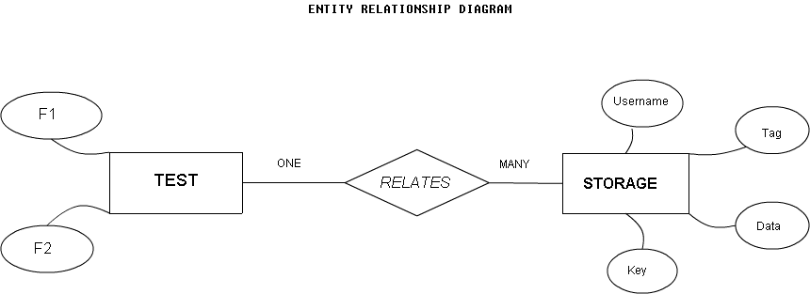

The web application data layer comprises of only two entities:

Test and Storage

The attributes of these entities are:

1. Test
2. F1 : stands for field 1(username here)
3. F2: stands for field 2(encrypted data here)
4. Storage
5. Username: For username
6. Tag: For data tag or label used to refer the data.
7. Data: Store the actual data which is to be encrypted.
8. Key: Encryption key used to encrypt the data.

The relationship between these entities is ONE-MANY, with MANY on the Storage side. The attribute username/F1 acts as a foreign key for the Storage table.

2. The table design used for the tables of database are as follows.

Test Table

TEST(F1,F2)

Create table statement:

Create table TEST(F1 varchar2(50) Primary Key, F2 varchar(1000) not null);

Storage Table

STORAGE(

USERNAME varchar2(50) not null,

TAG varchar2(50) not null,

DATA varchar2(1000) not null,

KEY int not null

Foreign key(USERNAME) references Test(F1));